**Automation Testing Document for API Testcases**

**API TESTING**

We need to test API and API testing is testing of endpoints before user interface design, so we can verify functionality early in the software development lifecycle

**Referred reqres.in for sample API’s**

Here we will find various API endpoints

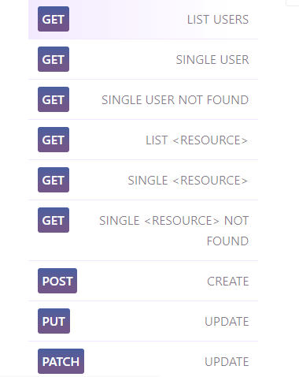

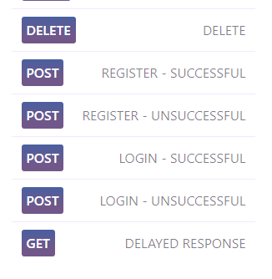

Here , I used postman API for to get requests response

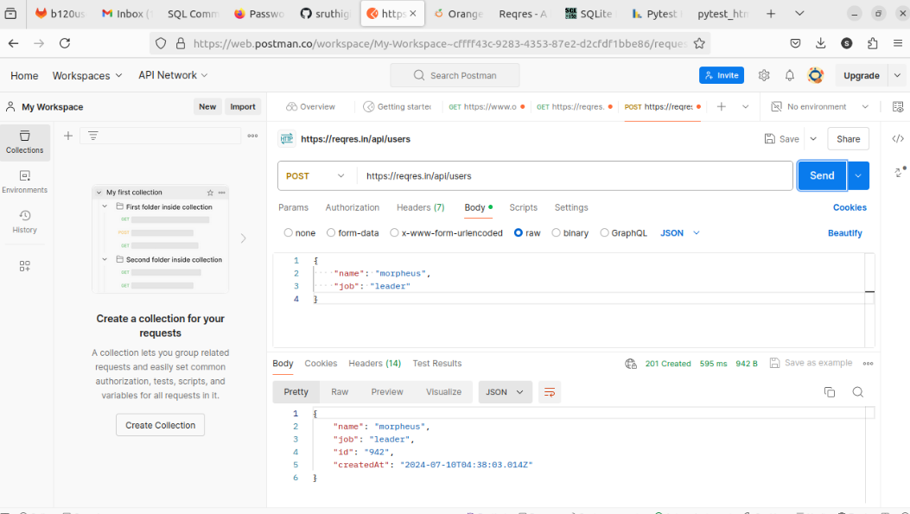

**Filename:** api_automation.py

**import requests**

**# res = requests.get('https://reqres.in/api/users?page=2')**

**# print(res)**

**"Automation list user endpoint"**

**def test_list_users():**

**res = requests.get('https://reqres.in/api/users?page=2')**

**print(res.status_code)**

**assert res.status_code == 200, "list user not exists"**

**def test_delete_users():**

**res=requests.delete('https://reqres.in/api/users/2')**

**print(res.status_code)**

**assert res.status_code==204, "cannt delete"**

**def test_create_users():**

**data={**

**"name": "morpheus",**

**"job": "zion resident"**

**}**

**res=requests.put('https://reqres.in/api/users/2')**

**assert res.status_code == 200, "update user failed"**

**def test_create_users1():**

**data={**

**"name": "morpheus",**

**"job": "zion resident"**

**}**

**res=requests.post('https://reqres.in/api/users')**

**assert res.status_code == 201, "update user1"**

**def test_create_users2():**

**data={**

**"name": "morpheus",**

**"job": "zion resident"**

**}**

**res=requests.patch('https://reqres.in/api/users/2')**

**assert res.status_code == 200, "update user2"**

**def test_list1_users():**

**res=requests.get('https://reqres.in/api/users/2')**

**assert res.status_code == 200, "get single user data"**

**def test_list_not_users():**

**res=requests.get('https://reqres.in/api/users/23')**

**assert res.status_code == 404, "not getting single user data"**

**def test_reg_successful_users():**

**data={**

**"email": "eve.holt@reqres.in",**

**"password": "pistol"**

**}**

**res=requests.post('https://reqres.in/api/register',data=data)**

**assert res.status_code == 200, "register successful user data"**

**def test_reg_unsuccessful_users():**

**data={**

**"email": "sydney@fife"**

**}**

**res=requests.post('https://reqres.in/api/register')**

**assert res.status_code == 400, "register unsuccessful user data"**

**def test_login_successful_users():**

**data={**

**"email": "eve.holt@reqres.in",**

**"password": "cityslicka"**

**}**

**res=requests.post('https://reqres.in/api/login',data=data)**

**assert res.status_code == 200, "login successful user data"**

**def test_login_unsuccessful_users():**

**data={**

**"email": "peter@klaven"**

**}**

**res=requests.post('https://reqres.in/api/login')**

**assert res.status_code == 400, "login unsuccessful user data"**

**def test_delay_users():**

**res=requests.get('https://reqres.in/api/users?delay=3')**

**assert res.status_code == 200, "delay user data"**

**def test_list_res_users():**

**res=requests.get('https://reqres.in/api/unknown')**

**assert res.status_code == 200, "resource list user data"**

**def test_single_res_users():**

**res=requests.get('https://reqres.in/api/unknown/2')**

**assert res.status_code == 200, "single resources user data"**

**def test_single_res_unsuccess_users():**

**res=requests.get('https://reqres.in/api/unknown/23')**

**assert res.status_code == 404, "single resources unsuccess user data"**

**Run the program using these below commands:**

**Python api_automation.py**

**Pytest api_automation.py**

**Output:as 15 test cases passes**

**To genereate the pytest report**

**Pip3 install pytest -html-reporter**

**Pytest - -html -report=./report**

